AWS Hands-On: AWS EBS Volume Addition

Amazon Elastic Block Store (Amazon EBS) provides scalable, high-performance block storage resources that can be used with Amazon Elastic Compute Cloud (Amazon EC2) instances. With Amazon Elastic Block Store, you can create and manage the following block storage resources:
- Amazon EBS volumes — These are storage volumes that you attach to Amazon EC2 instances. After you attach a volume to an instance, you can use it in the same way you would use a local hard drive attached to a computer, for example to store files or to install applications.
- Amazon EBS snapshots — These are point-in-time backups of Amazon EBS volumes that persist independently from the volume itself. You can create snapshots to back up the data on your Amazon EBS volumes. You can then restore new volumes from those snapshots at any time.

In this Hands-On, we are doing;
- Increasing the EBS root volume size of an EC2 instance using SSM Automation
- Adding an extra EBS volume to the instance and make it available for use.

Increasing the EBS root volume size using SSM Automation:
Customers have been using various forms of automation for years to define a sequence of actions on EBS. While before, customers were facing operational overhead related to EBS tasks, AWS System manager (SSM) can now be leveraged to meet a wide variety of customer use cases.
The use case is to increase the volume size to the Target size of 20 GB without shutting down or rebooting the instance.
Before proceeding, we need to do the prerequisites:
- Create an IAM role named “SSMManagedEC2Role” with “AmazonSSMMangedInstanceRole” permissions policies.

If you want to manage your EC2 instances using AWS Systems Manager, you would typically create an IAM role that includes the AmazonSSMManagedInstanceCore policy. Then, you would attach this role to your EC2 instances via an instance profile. This setup allows the instances to communicate with SSM, perform tasks like patch management, inventory collection, and use the Session Manager for secure shell access without needing an SSH key or opening inbound ports.

- Launch an EC2 Instance must be managed by SSM.
- AutomationAssumeRole is an Identity and Access Management (IAM) role for this execution of this document. If no role is specified, AWS SSM Automation will utilize your IAM permissions to execute this document.

Step1: Checking the root volume size of our Demo Instance.
- Connecting to the EC2 instance using Session Manager

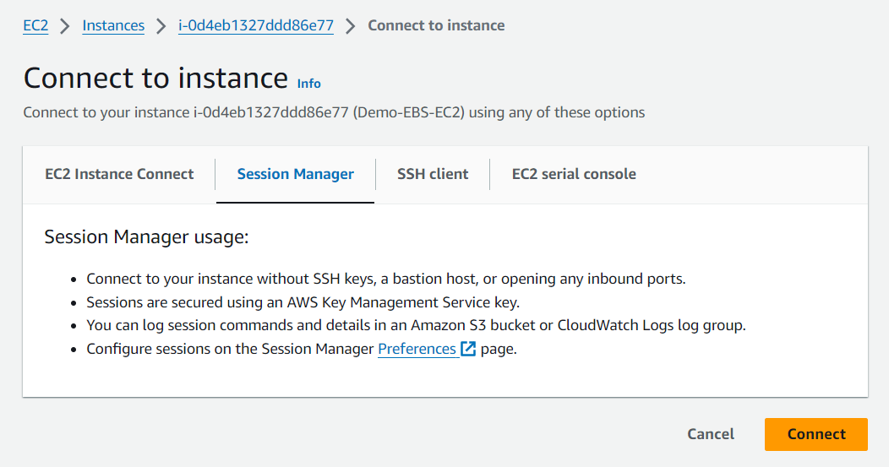

- Run the “lsblk” command for view the volumes.

Here we can see the current root volume of 10GB was mounted on the mount point /.

Also, we can use “df -Th” command display information about the disk space usage of all mounted filesystems in a human-readable format, along with the filesystem type.

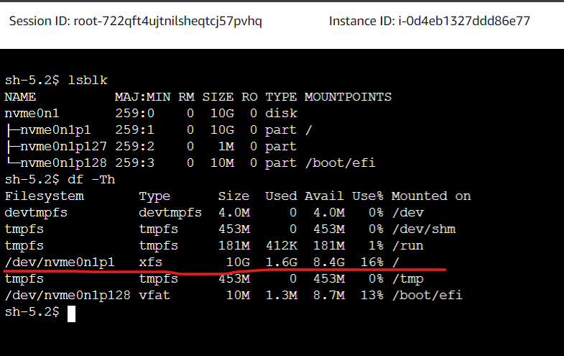

Step2: Now, let’s use “AWS-ExtendEbsVolume” Automation Document to extend the EBS Volume:
- Open the AWS SSM via AWS Management Console, and Type “System Manager”
- In the navigation pane, choose Automation > Choose Execute Automation.
- In the Choose runbook section, under Automation runbook, search for the document named, “AWS-ExtendEbsVolume”. Click on the document to execute it.

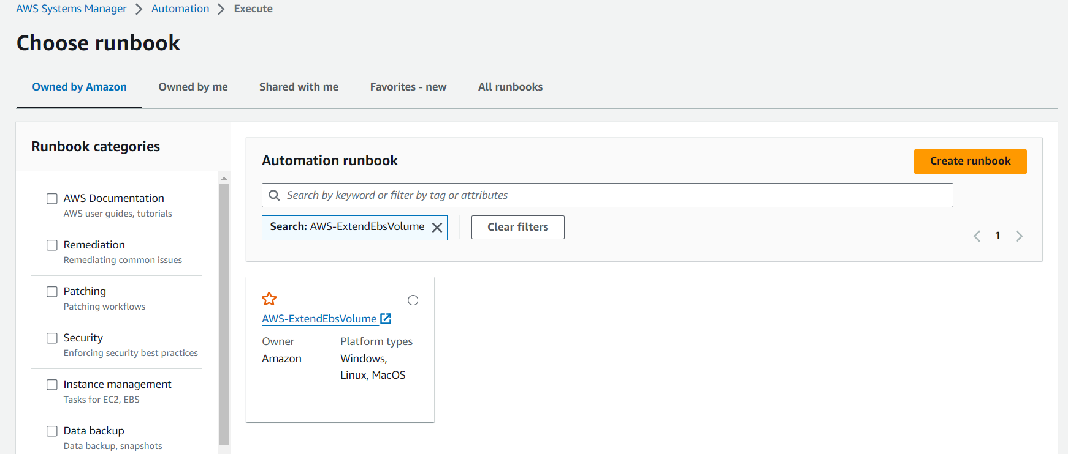

- Click on Execute automation to run the automation workflow.
- Provide the below details in Input Parameters section;
- VolumeId: ID of the volume which you want to extend. You will specify this ID in the procedure.
- SizeGib: Size Gib is the target size of the volume, in Gib of the same volume for which you provided the Volume ID. The target volume size must be greater than or equal to the existing size of the volume.
- MountPoint: (Required for Linux) Mount point (a directory or file at which a new file system, directory, or file is made accessible) such as “/”, “/data” etc. of the partition which is to be increased.
- DriveLetter: (Required for Windows) Drive Letter for Windows is needed to increase the size of the existing volume.
- InstanceId: The ID of the Amazon EC2 instance that the Amazon EBS volume you want to extend is attached to.

and then click the “Execute” button to start the Automation workflow:

Step 3: Observations
- Once you click the “Execute” button, the automation will start, and you can see the status as “In Progress”.
- See more details under executed steps.
- You can always check the details of each “Execution ID” and its associated steps using “Step ID”.
You can see the Execution “Overall status” under automation is “Success”.
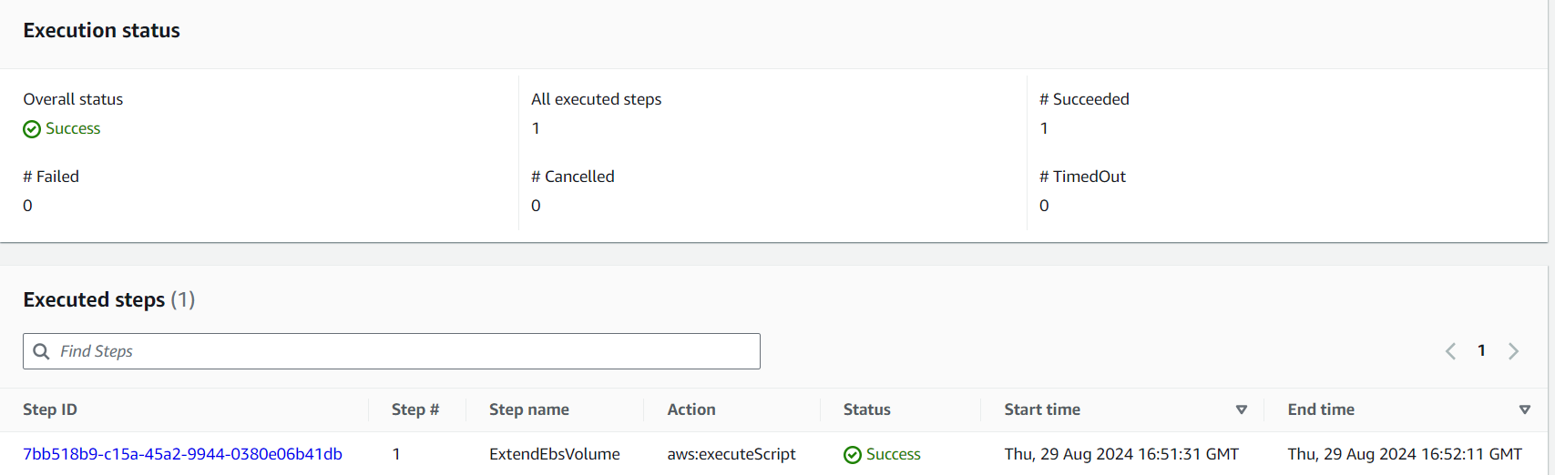

As the result of our execution of SSM Automation, we can see the root volume size increased from 10GB to 20GB.
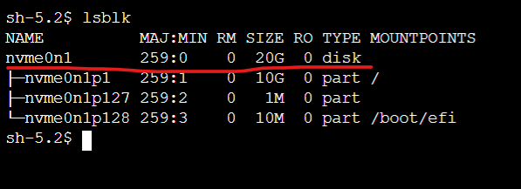
Then our first session was completed.

Attach an EBS volume and make available for use:
Here we are attaching an available EBS volume to one or more of your instances that is in the same Availability Zone as the volume.
Here we are created and EBS volume and attached to the instance.
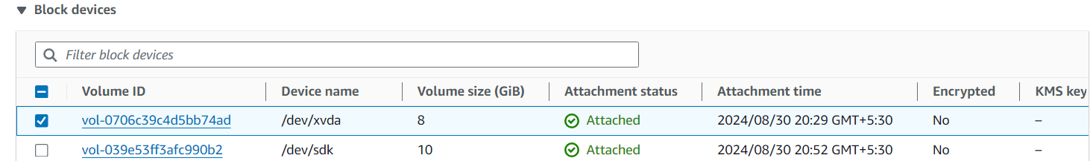

After you attach an Amazon EBS volume to your instance it is exposed as a block device. You can format the volume with any file system and then mount it. After you make the EBS volume available for use, you can access it in the same ways that you access any other volume.
The below steps can use to make the newly attached volume available for use.
Connect to your instance using SSH.

- List available disks

Run the lsblk -l command to view your available disk devices and their mount points.

On the below image we can see that the details;

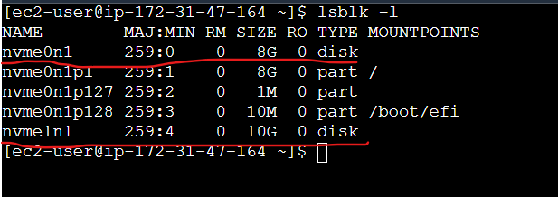

- The root device is nvme0n1, which has one partition named nvme0n1p1.
- The attached volume is nvme1n1, which has no partitions and is not yet mounted.

- Determine File system:

New volumes are raw block devices, and you must create a file system on them before you can mount and use them.

Use the file -s command to get information about a specific device, such as its file system type. If the output shows simply data, as in the following example output, there is no file system on the device

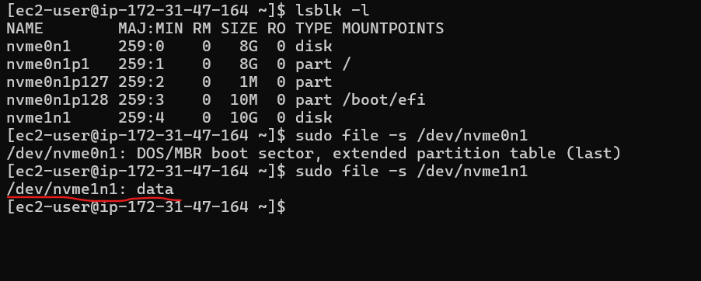

Also, we can use sudo lsblk -f command to view;

- Identifying Volumes: Helps identify which devices are mounted where and what file systems they use.
- UUIDs: Useful for obtaining UUIDs to use in /etc/fstab.
- Mount Points: Shows where each device is mounted, which is crucial for managing disk usage and verifying configurations.
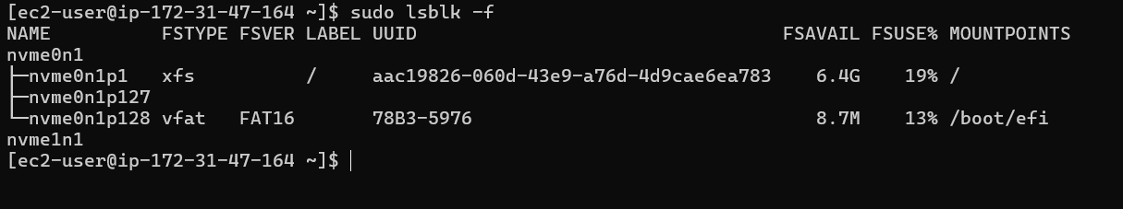

- Crete file system for the volume:
We can use the mkfs -t command to create a file system on the volume.
Run the command sudo mkfs -t xfs /dev/nvme1n1 to make the file system of the device /dev/nvme1n1.
Breakdown of the Command
- sudo: Runs the command with superuser privileges, which are required to create a file system.
- mkfs: Stands for "make file system." It's a command used to format a partition or block device with a file system.
- -t xfs: Specifies the type of file system to create. The -t flag stands for "type," and xfs is the file system type being created.
- /dev/nvme1n1: This is the block device where the file system will be created.
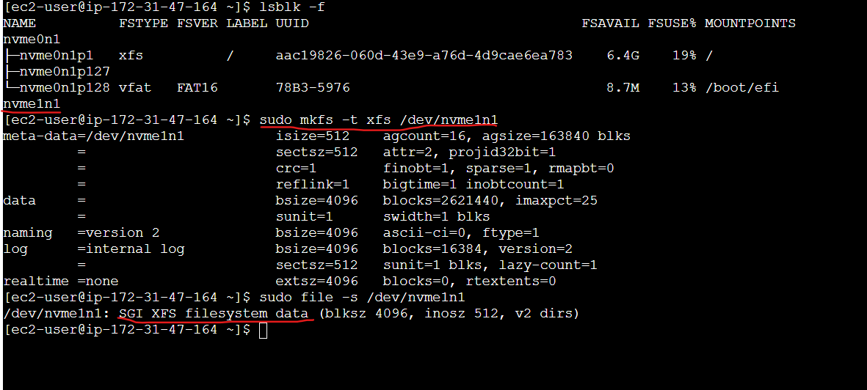
- Create a mount point directory for the volume:

Run the command sudo mkdir /mydata create a mount point directory to mount the volume.

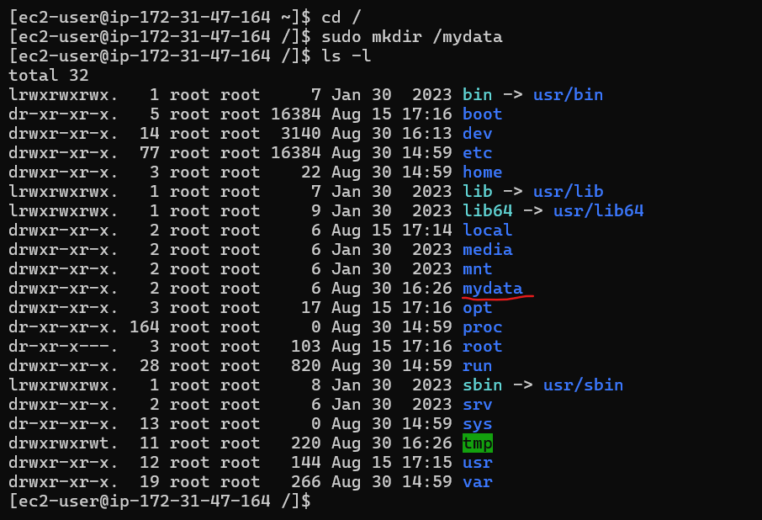

- Mount the volume to the /mydata directory.

Mount the volume or partition at the mount point directory you created in the previous step.If the volume has no partitions, use the following command and specify the device name to mount the entire volume.
sudo mount /dev/nvme1n1 /mydata

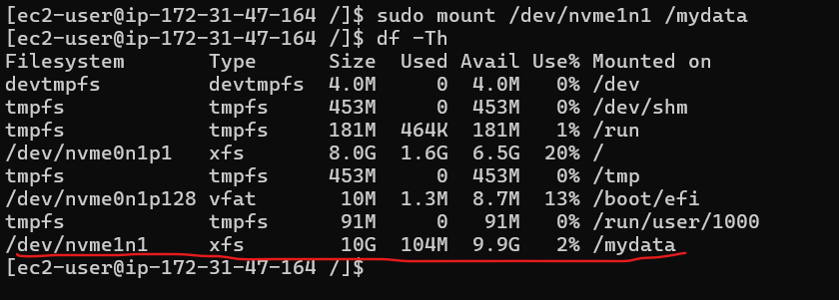
From the above snap we can verify that, our EBS volume /dev/nvme1n1 with 10GB in size and xfs file system was mounted on /mydata mount point.

Automatically mount an attached volume after reboot:

Whether an attached EBS volume is automatically mounted after an EC2 instance reboot depends on how the volume was configured.

Scenario 1: EBS Volume Used as the Root Volume
Automatically Mounted: The root EBS volume (usually mounted at /) is automatically mounted on boot by default. This is because it's required for the operating system to function.

Scenario 2: Additional (Non-Root) EBS Volumes
Not Automatically Mounted by Default: If you have additional EBS volumes attached to the instance, they are not automatically mounted after a reboot unless explicitly configured to do so.

To mount an attached volume automatically after reboot

Use the lsblk -f command to find the UUID of the device.

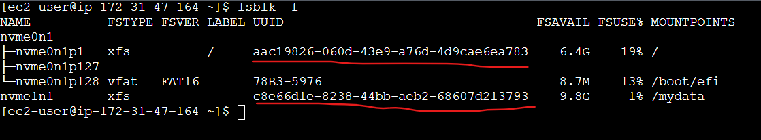

Add an Entry to /etc/fstab:

To make sure the volume is mounted automatically on reboot, you should add an entry for it in the /etc/fstab file.

You can use the device name, such as /dev/xvdf, in /etc/fstab, but we recommend using the device's 128-bit universally unique identifier (UUID) instead. Device names can change, but the UUID persists throughout the life of the partition.

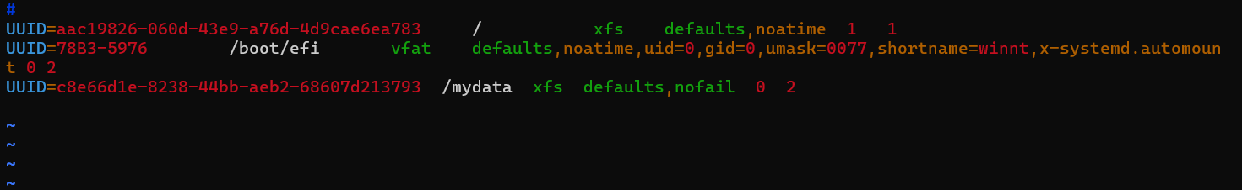

- UUID=c8e66d1e-8238-44bb-aeb2-68607d213793: This is the UUID of the device file that represents the EBS volume attached to your EC2 instance.

- /mydata: This is the directory on your file system where the EBS volume will be mounted.

- Xfs: This specifies the file system type used on the EBS volume.

- defaults: This is a set of default mount options that define how the file system should be mounted.

Customizing: You can replace defaults with specific options if needed, like ro for read-only.

- nofail: The nofail option ensures that the boot process continues even if this particular volume cannot be mounted.

- 0 (Dump Option): This field controls whether the dump utility will back up the file system.
    - 0 means don't include this file system in dump backups.
    - 1 would include it.

- 2 (Pass Option): This field determines the order in which file systems are checked by fsck during boot.

Value:
- 1 is used for the root file system (/), and it will be checked first.
- 2 means this file system will be checked after the root file system.
- 0 means don't check this file system at boot.

You can test if the /etc/fstab entry is correct without rebooting by running.

sudo mount -a

If there are no errors, the configuration is likely correct, and the volume will mount automatically after the next reboot.

